**DAILY ONLINE ACTIVITIES SUMMARY**

|  |  |  |  |  |  |  |  |  |
| --- | --- | --- | --- | --- | --- | --- | --- | --- |
| **Date:** | 11-06-2020 | | | | | **Name:** | Anvitha H M | |
| **Sem & Sec** | 4th ‘A’ | | | | | **USN:** | 4AL18CS010 | |
| **Online Test Summary** | | | | | | | | |
| **Subject** | | N/A | | | | | | |
| **Max. Marks** | | - | | **Score** | | | - | |
| **Certification Course Summary** | | | | | | | | |
| **Course** | Front end development - CSS. | | | | | | | |
| **Certificate Provider** | | | Great learning academy | | **Duration** | | | 8 hours |
| **Coding Challenges** | | | | | | | | |
| **Problem Statement:** Java program to segregate the even and odd numbers in an array. | | | | | | | | |
| **Status:** Executed | | | | | | | | |
| **Uploaded the report in Github** | | | | | YES | | | |
| **If yes Repository name** | | | | | <https://github.com/alvas-education-foundation/Anvitha-H-M> | | | |
| **Uploaded the report in slack** | | | | | Yes | | | |

**Online test:**  N/A

**Certification course:**

Front end development - CSS

The course includes detailed explanation on class selector, attribute selector and pseudo class selector, hover pseudo class selector with exercising quiz.

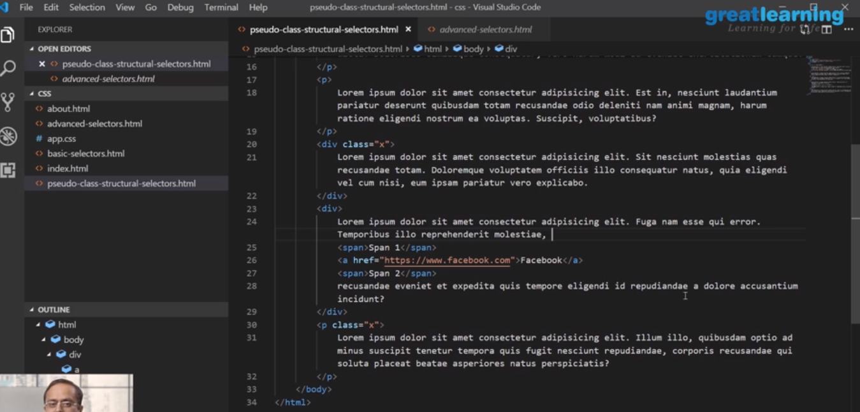

Online coding challenge

The programing statement of the day is

“Program in Java to segregate the even and odd numbers in an array.”

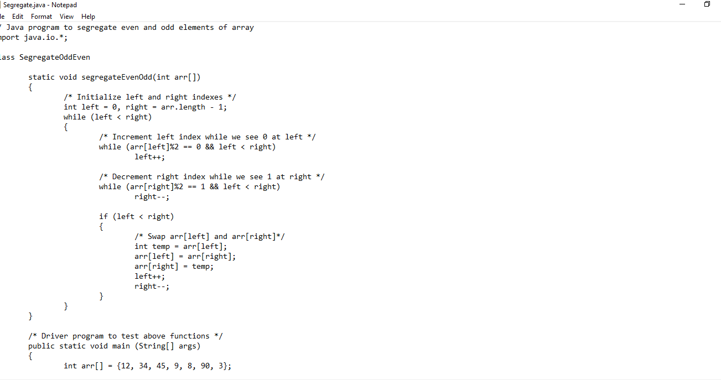

Solution: Executed and uploaded in Github repository.

Link: <https://github.com/alvas-education-foundation/Anvitha-H-M>